# Project Name: Implement Spring Security with Authentication.

## GitHub Link:

## <https://github.com/tamasjit/myjavaproject/tree/master/Phase%203/Phase-3_Practice_Project/q4_SpringSecurityMW>

## Output:

### Landing Page:

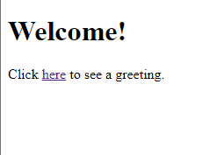

### Login Page:

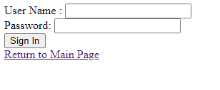

### Entering Credentials:

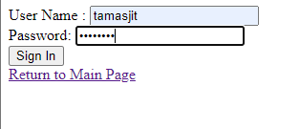

### Correct Credential Successful message:

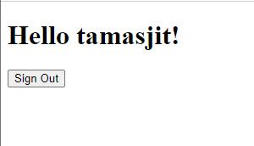

### Wrong Credential input:

